Tugas 5

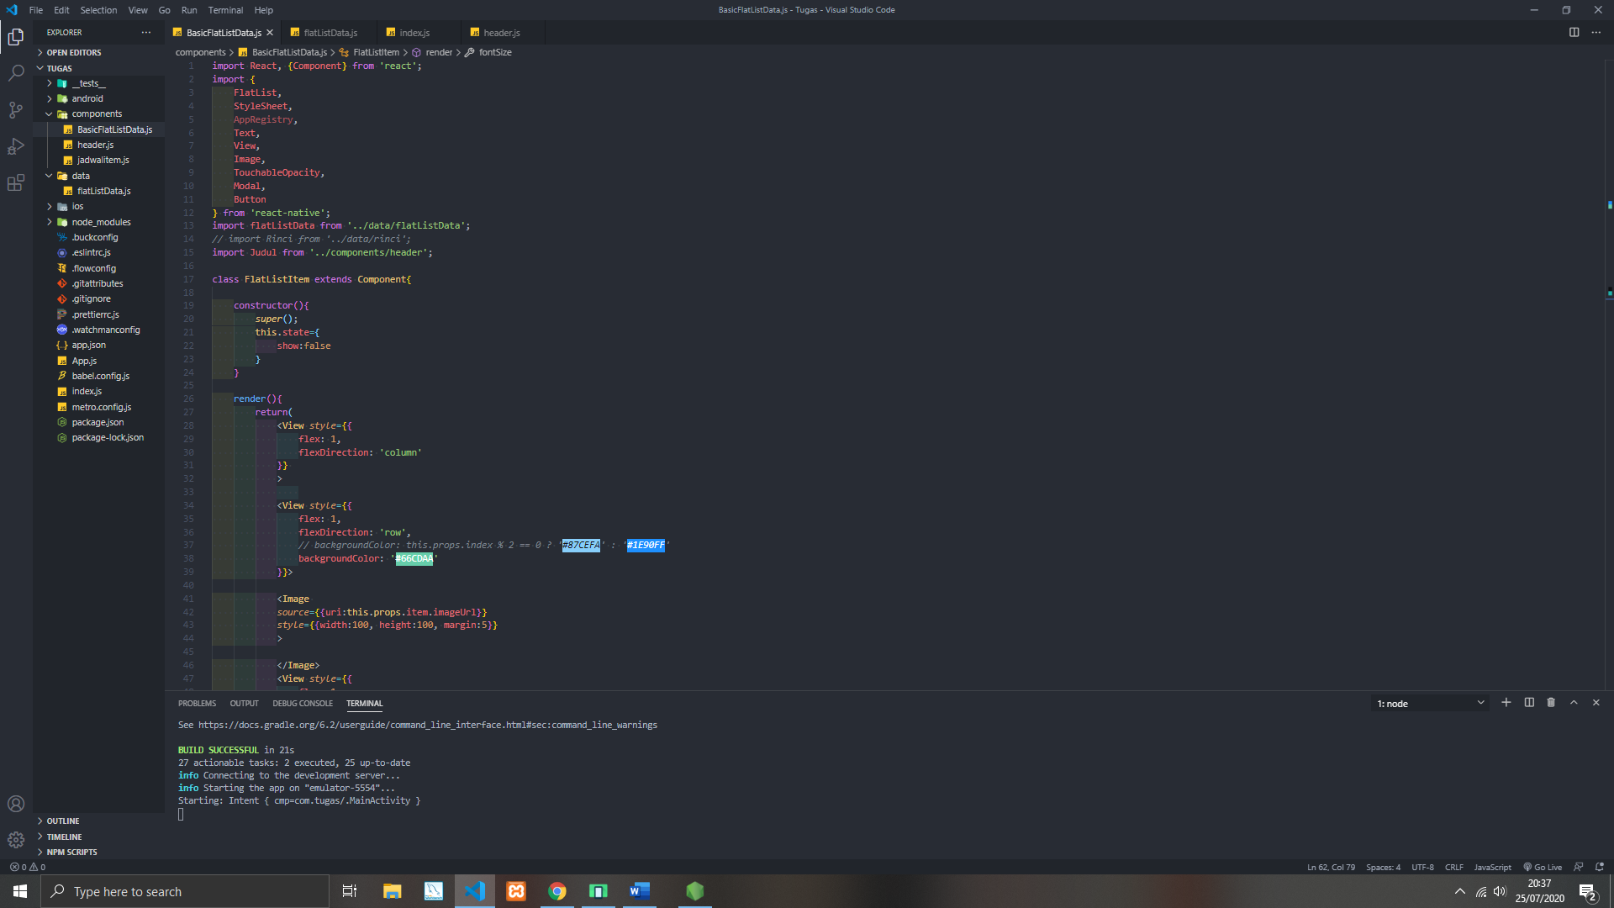

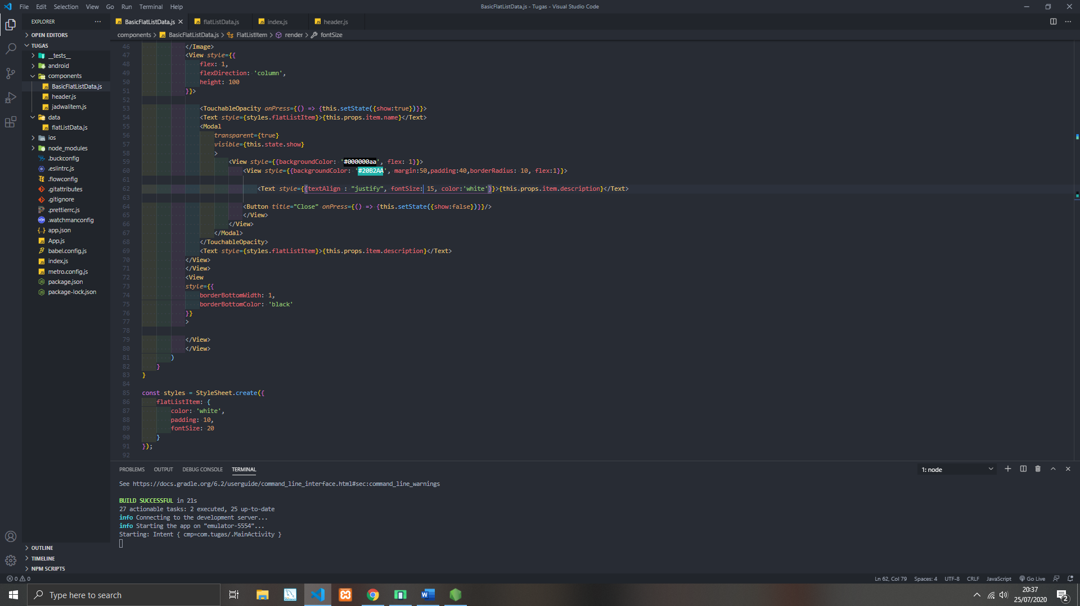

Coding BasicFlatListData

import React, {Component} from 'react';

import {

    FlatList,

    StyleSheet,

    AppRegistry,

    Text,

    View,

    Image,

    TouchableOpacity,

    Modal,

    Button

} from 'react-native';

import flatListData from '../data/flatListData';

*// import Rinci from '../data/rinci';*

import Judul from '../components/header';

class FlatListItem extends Component{

    constructor(){

*super*();

        this.state={

            show:false

        }

    }

    render(){

        return(

            <View *style*={{

                flex: 1,

                flexDirection: 'column'

            }}

            >

            <View *style*={{

                flex: 1,

                flexDirection: 'row',

*// backgroundColor: this.props.index % 2 == 0 ? '#87CEFA' : '#1E90FF'*

                backgroundColor: '#66CDAA'

            }}>

            <Image

*source*={{uri:this.props.item.imageUrl}}

*style*={{width:100, height:100, margin:5}}

            >

            </Image>

            <View *style*={{

                flex: 1,

                flexDirection: 'column',

                height: 100

            }}>

                <TouchableOpacity *onPress*={() => {this.setState({show:true})}}>

                <Text *style*={styles.flatListItem}>{this.props.item.name}</Text>

                <Modal

*transparent*={true}

*visible*={this.state.show}

                    >

                        <View *style*={{backgroundColor: '#000000aa', flex: 1}}>

                            <View *style*={{backgroundColor: '#20B2AA', margin:50,padding:40,borderRadius: 10, flex:1}}>

                                <Text *style*={{textAlign : "justify", fontSize: 15, color:'white'}}>{this.props.item.description}</Text>

                            <Button *title*="Close" *onPress*={() => {this.setState({show:false})}}/>

                            </View>

                        </View>

                    </Modal>

                </TouchableOpacity>

                <Text *style*={styles.flatListItem}>{this.props.item.description}</Text>

            </View>

            </View>

            <View

*style*={{

                borderBottomWidth: 1,

                borderBottomColor: 'black'

            }}

            >

            </View>

            </View>

        )

    }

}

const styles = StyleSheet.create({

    flatListItem: {

        color: 'white',

        padding: 10,

        fontSize: 20

    }

});

export default class BasicFlatListData extends Component {

    render(){

        return (

            <View *style*={{flex:1}}>

                <Judul/>

                <FlatList

*data*={flatListData}

*renderItem*={({*item*, *index*}) => {

                    return (

                        <FlatListItem *item*={*item*} *index*={*index*} >

                        </FlatListItem>

                    );

                }}

                >

                </FlatList>

            </View>

        )

    }

}

Hasilnya

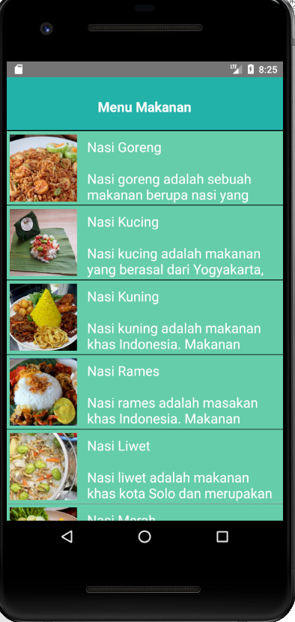

Hasil Pas di klik name / nasi goreng nya

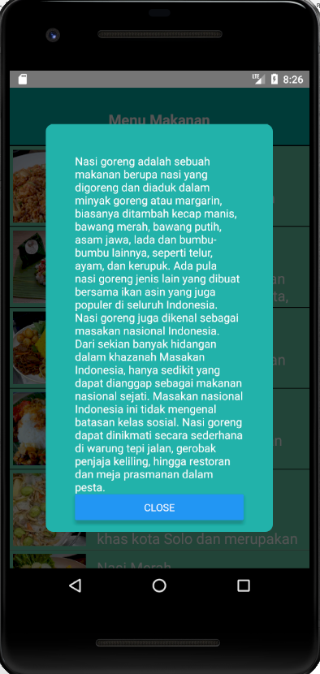

Hasil Pas di klik close kembali ke semula

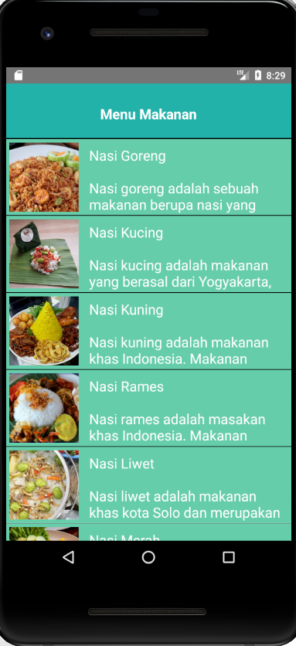

Hasil pas di klik name / nasi kucing

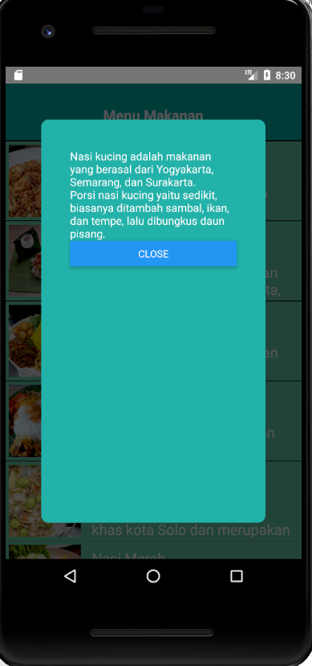

Hasil pas di klik name / nasi kuning

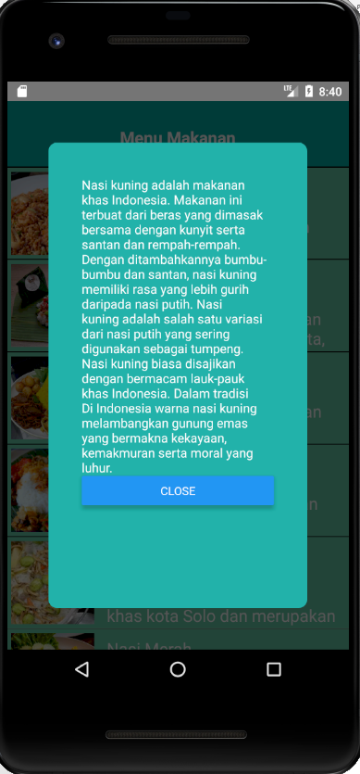

Hasil pas di klik name / nasi rames

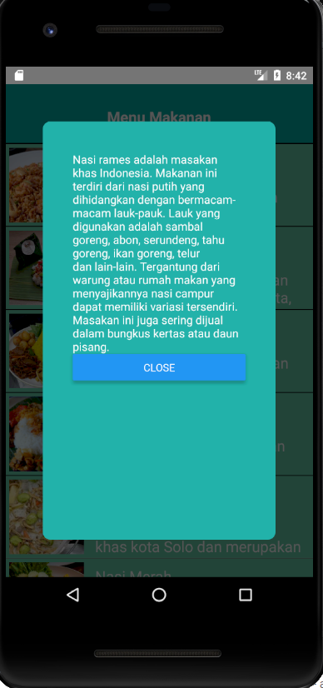

Hasil pas di klik name / nasi liwet

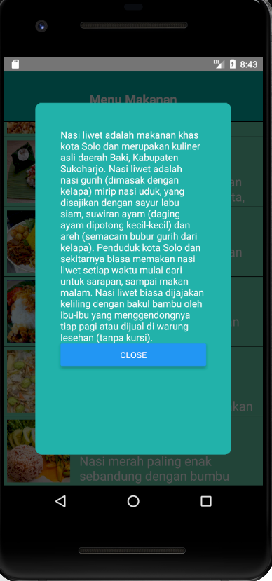

Hasil pas di klik name / nasi merah

